Y1Q4W13

The Siege

Ask the following, substituting the names below: If ____________ told you they were going to give you $10 would you believe them?
- Your friend
- Me
- Your parents
- Someone you didn't know
- Your teacher
- A police officer
- A kid you didn't know
- Your brother or sister

Ask the above question for $100 and then $1000
Ask: Why would you believe some things and not others?

Ask: Do you remember last weeks story, when the army was surrounding the city? Do you remember why the army came to that city?
Say: They came to capture Elisha, because he was told the king of Israel what his enemies were doing.

Bible Story

Ask: Should the king of Israel have believed Elisha? Why?
Sing Songs

Return to tables
Memory Verse: Fill in the blanks and then say the memory verse on the colouring page.
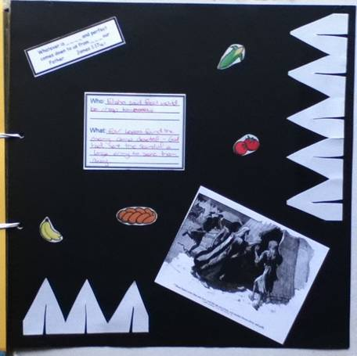
Scrapbooks
- Choose a cardboard
- Stick on Photo, Bible verse and Who/What Card
- Fold the strip of white paper in half three times and then cut as shown to make a row of tents
- Stick the food on

Discuss the following depending on age, interest and time:
Why would you, or would you not believe the people in part 1? Why?
Can we always believe God? How do we know?
Can you think of anything that God has said that applies to you?
Do you have a favourite Bible verse?
Do you know what a conditional promise is? Can you think of any conditional promises of God? (eg. John 15:7)

Show: The promise box – have each child pick out a promise and read it (adults will have to help young children to read)
Ask: What is your favourite promise?
Say: I have some pretty paper for you to copy your favourite promise onto to take home.

Finish with prayer

